WEST BENGAL PROFESSIONAL FISHERIES GRADUATES′ ASSOCIATION
(WBPFGA)
(West Bengal Societies Registration Act XXVI of 1961 No.39377 of 2006-07)

FACULTY OF FISHERY SCIENCES 5, BUDHERHAT ROAD, CHALKGARIA, KOLKATA-700094

Date: 07.01.2017 Place: Meen Bhaban, Siliguri

District Committee of Cooch Behar District

- Sri Samir Saha – President
- Sri Suman Kar – Secretary
- Sri Nandan Pramanick – Treasurer
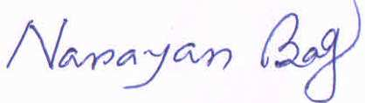
(Dr. Narayan Bag)
President, WBPFGA

