WEST BENGAL PROFESSIONAL FISHERIES GRADUATES′ ASSOCIATION
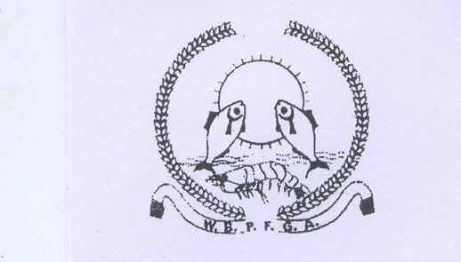
(WBPFGA)

(West Bengal Societies Registration Act XXVI of 1961 No.39377 of 2006-07)

FACULTY OF FISHERY SCIENCES 5, BUDHERHAT ROAD, CHALKGARIA, KOLKATA-700094

NOTICE

This is to inform you that the Central Executive Committee of WBPFGA will meet the all District members of South 24 Parganas on 16th December, 2016 at 3.30 pm onward at the FFDA meeting hall, Alipur, S 24 Pgs. The following activities will be performed during the meet:-
- District meeting
- District Committee formation for 2017 & 2018
- Miscellaneous
All members of WBPFGA of South 24 Parganas District are hereby requested to remain present in the meet without fail.
(Dr. Narayan Bag)
President, WBPFGA

