WEST BENGAL PROFESSIONAL FISHERIES GRADUATES′ ASSOCIATION
(WBPFGA)
(West Bengal Societies Registration Act XXVI of 1961 No.39377 of 2006-07)

FACULTY OF FISHERY SCIENCES 5, BUDHERHAT ROAD, CHALKGARIA, KOLKATA-700094

Date: 03.12.2016 Place: Meen Bhaban, Malda

District Committee of Uttar Dinajpur District

- Sri Prafulla Das – President
- Smt. Bidisha Mondal – Secretary
- Sri Arunava Chatterjee – Treasurer
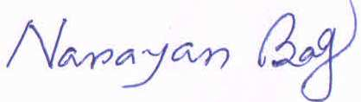
(Dr. Narayan Bag)
President, WBPFGA

